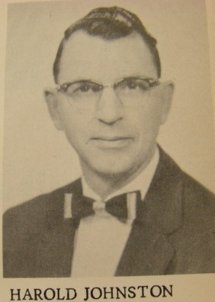
The Harold Johnston Year
1956-1957 (1 Season)

Overall Record: 3-16 (0.158)

Situation | Wins | Losses | Winning Pct.
Home Record | 1 | 7 | 0.125
Away Record | 2 | 9 | 0.182
League Record | 2 | 10 | 0.167
Non-League Record | 1 | 6 | 0.143
Regional Record | 0 | 1 | 0.000
State Record | 0 | 0 | 0.000

League Titles: 0

CKL Runner-Up Finishes: 0

State Appearances: 0

State Championships: 0

State Runner-Up: 0

State 3rd Place: 0

Revised: 4/7/2014

